**BLG368E - Object Oriented Modeling and Design**

**Assignment 4**

Kadir Emre Oto (150140032)

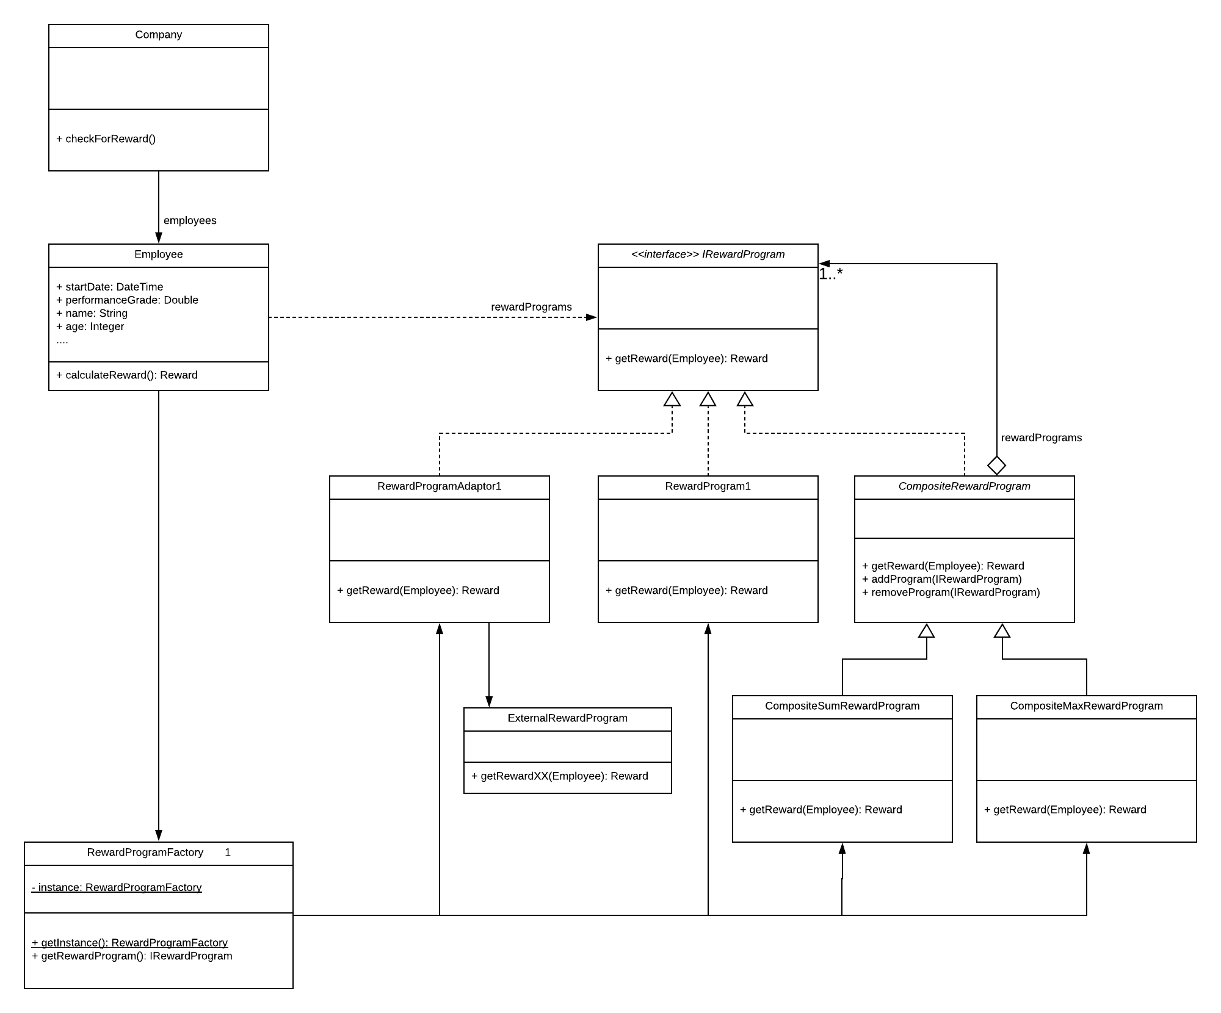

Figure 1: Class Diagram

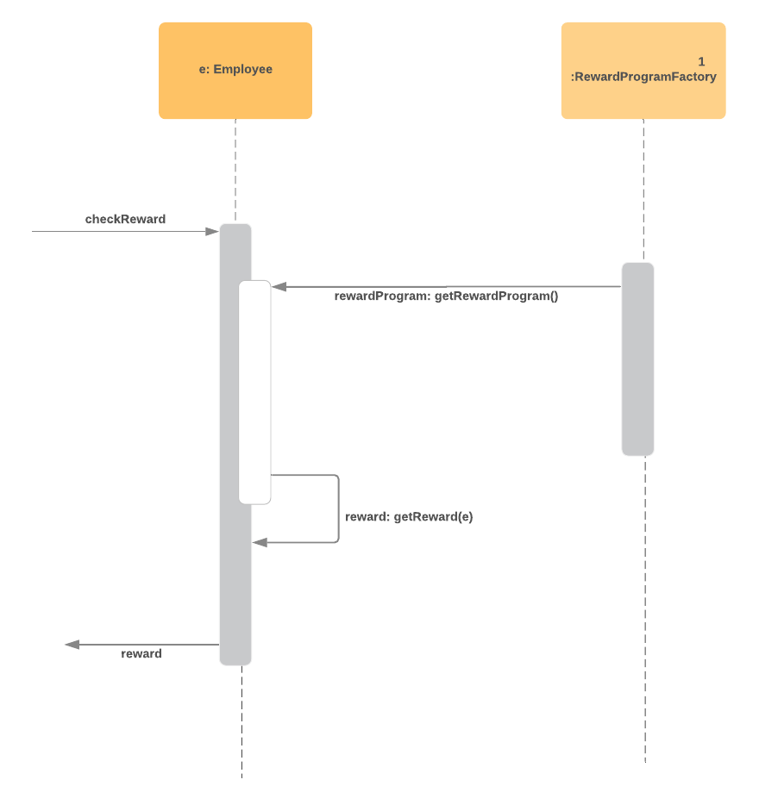

Figure 2: Sequential Interaction UML Diagram